Lab 6

Screenshots:

Get all books:

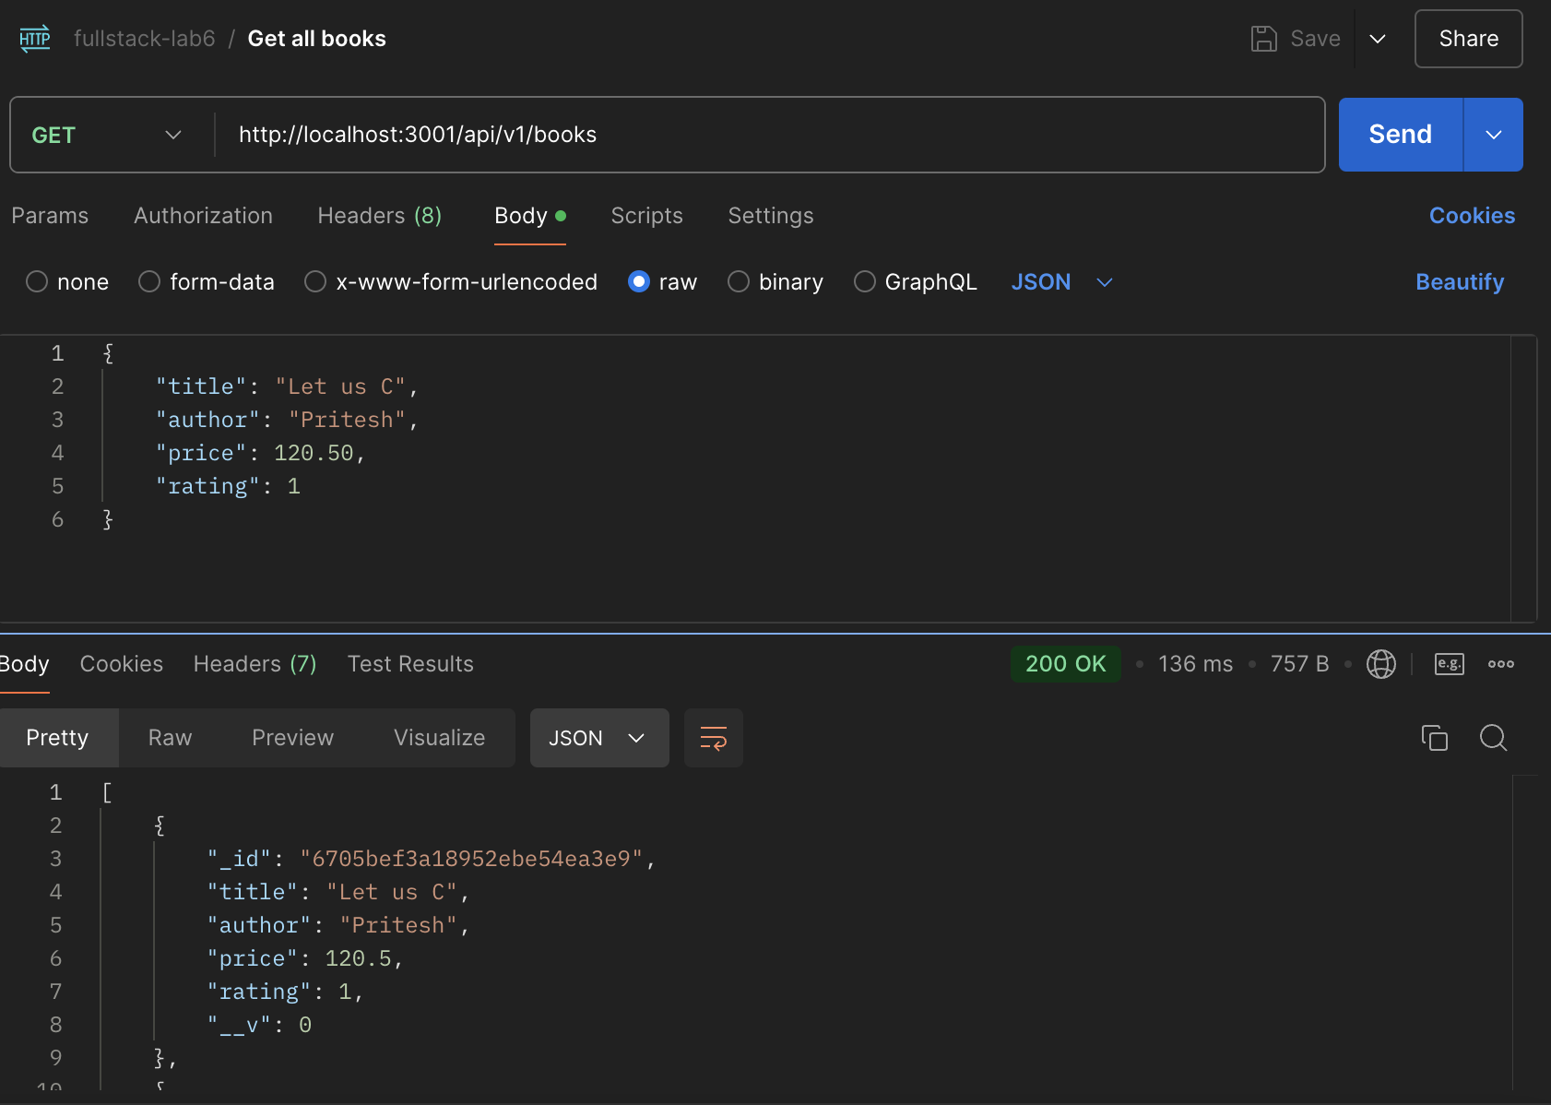

Post a book:

Update a book:

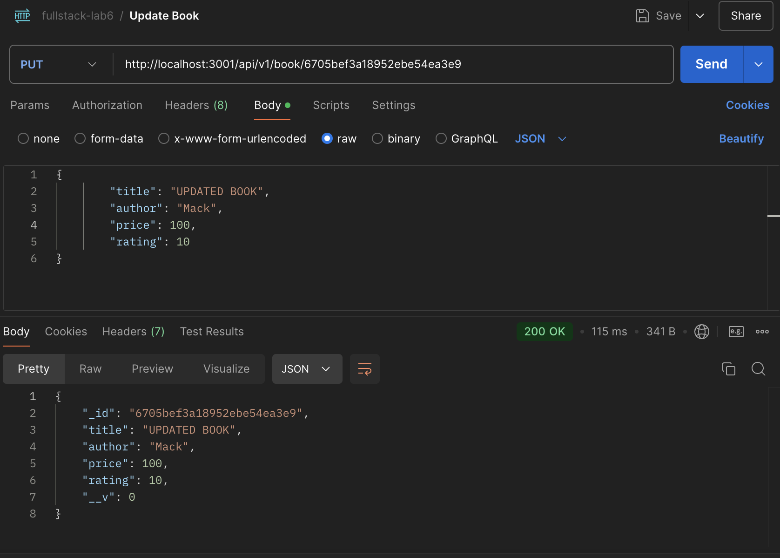

Delete a book:

